## Getting Up and Running with the Power BI Service

**Setup Time**: 60 minutes

**Lab Folder**: C:\Student\Modules\01_Intro\Lab

**Overview**: This lab will teach you how to get up and running with the Power BI service to prepare for Power BI development. You will start by copy the student files to your local workstation. Next, you will log into an Azure AD user account that has been created for you in an Azure AD tenant shared by all students which has a domain name of **powerbimvps.onmicrosoft.com**. Once you have logged into the Power BI service and started your 60 Power BI Pro trial, you will be able to upload PBIX files into your personal workspace and you can begin designing dashboard and reports in the browser. The lab will also step you through downloading and installing Power BI Desktop as well as publishing a Power BI Desktop project to the Power BI service. You create a new app workspace and populate it with a dataset, a report and a dashboard. In the final exercise, you will use the Publish to Web feature together with Visual Studio to embed a Power BI report in a custom web page.

### Exercise 1: Copy the Student Lab Files to Your Local PC

Student files for this course are maintained in a GitHub fil repository at <https://github.com/CriticalPathTraining/DevInADay>. You will download the student files from there so you have a local copy on your PC workstation.

1. Navigate to the github repository for this workshop at <https://github.com/CriticalPathTraining/DevInADay/>.

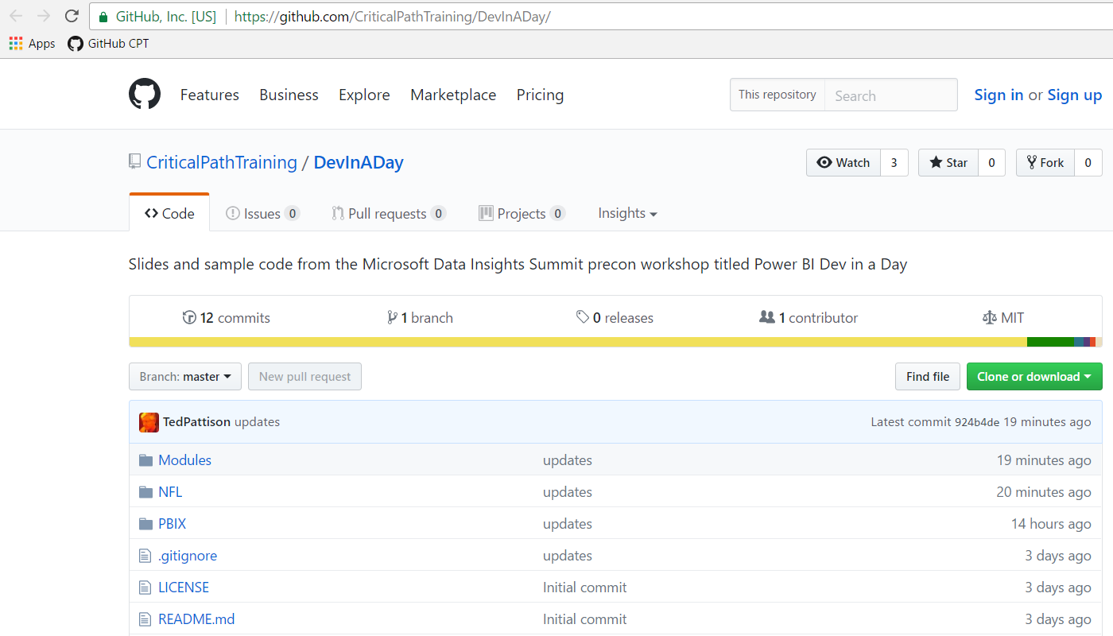

1. If you have GIT installed, you can run the following command to automate downloading the student files to your PC.

git clone https://github.com/CriticalPathTraining/DevInADay.git c:\Student

1. If you do not have GIT installed, you can download the master zip archive and extract the contents in a local folder.
   1. Click on the following link: <https://github.com/CriticalPathTraining/DevInADay/archive/master.zip>.
   2. Once you have downloaded this zip archive you can extract the contents into a local directory named **C:\Student**.
2. You should have now copied the student files for this workshop into a local folder named **C:\Student**.

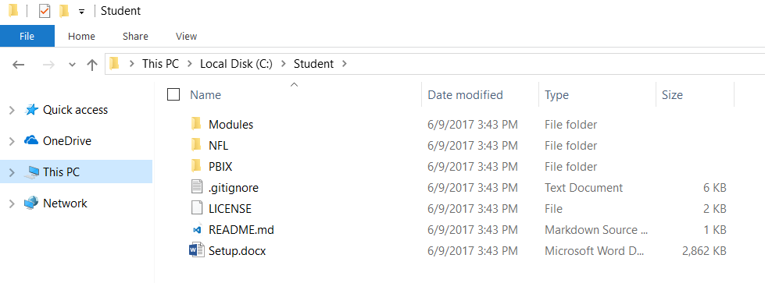

### Exercise 2: Log into your User Account and Access the Power BI Service

In this exercise, you will log into an Azure Active Directory account that has been created for you to work inside the Power BI environment to complete the lab exercises for this workshop. The account you will use has been created in an Azure AD tenancy with a domain of **powerbimvps.onmicrosoft.com**. Once you log in, you will be prompted to accept a Power BI Pro trial for 60 days able to access the Power BI service. Once you accept the 60 day trial, you will be able to access your personal workspace and begin creating datasets, reports and dashboards.

1. Make sure you have obtained the following information from the instructor about your user account:
   1. user account name (e.g. **CritialPathUser42.powerbimvps.onMicrosoft.com**)
   2. Password: **Pass@word1**
2. Log into the Power BI service using your new user account.
   1. Open a browser such as Chrome, Edge or Internet Explorer.
   2. Navigate to the following URL:

<https://app.powerbi.com>

* 1. When prompted to sign in, enter the user account name that has been provided to you and a password of **Pass@word1**. Click the **Sign in** button to begin the initial log in sequence.

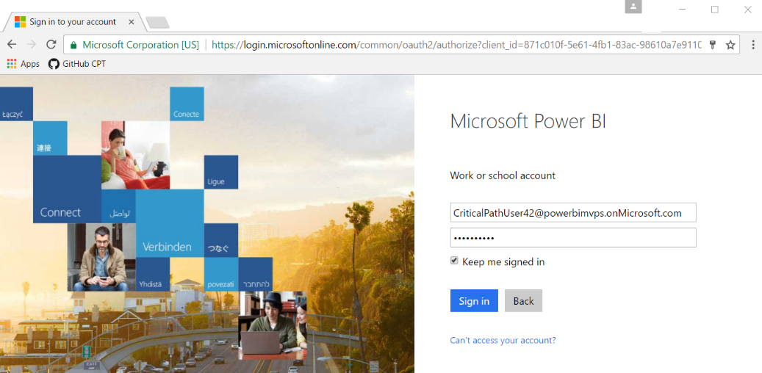

* 1. When prompted to update your password, enter a new password that you can remember for the entire day of this workshop ;)

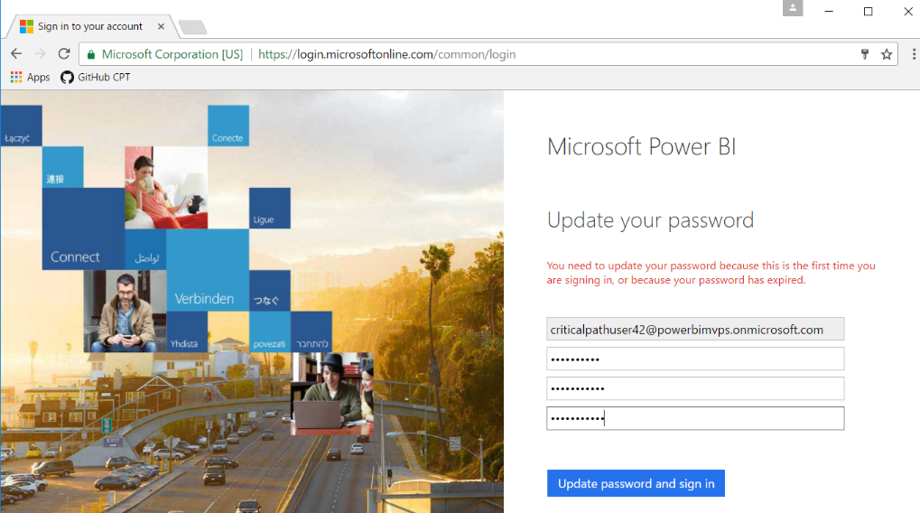

* 1. You should now be prompted with a Power BI Sign in page. Click **Sign in**.

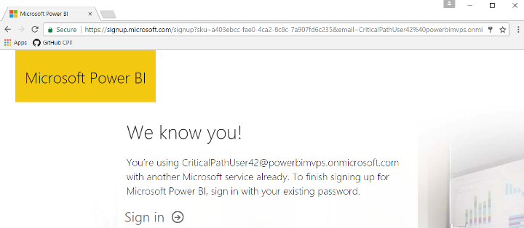

* 1. Next click the **Start** button.

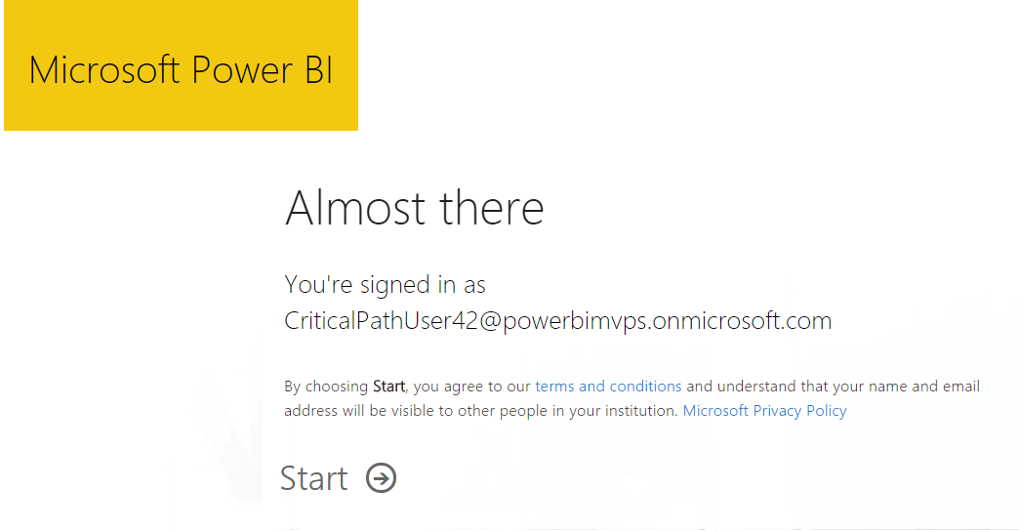

* 1. Skip by the next page which asks if you want to invite more people.

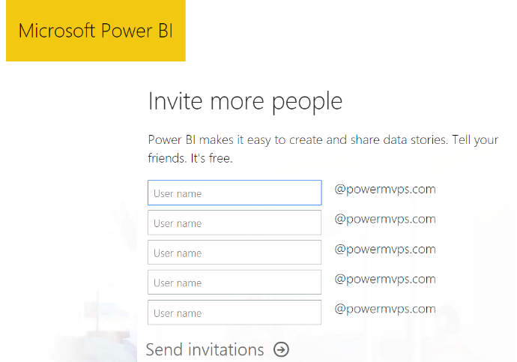

* 1. When you see the **Welcome to Power BI** dialog as shown in the following screenshot, click the **Yes, start trial!** Button.

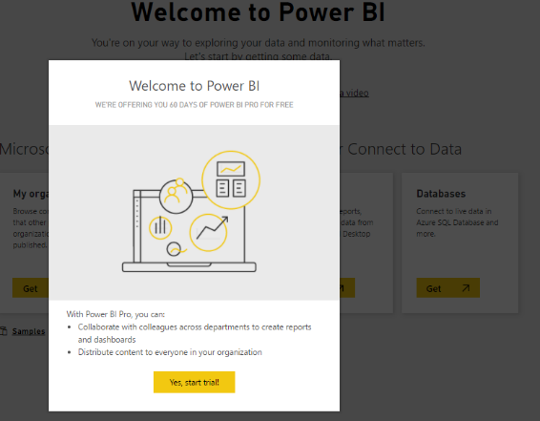

* 1. You should now be signed into Power BI and running within your personal workspace.

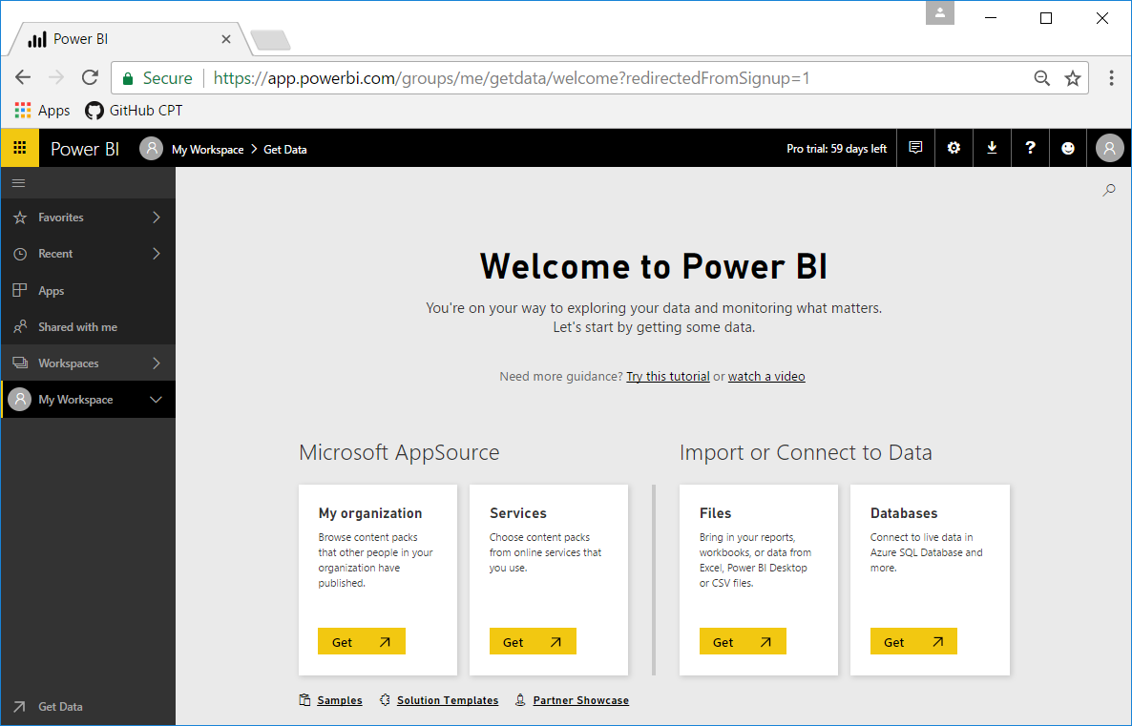

### Exercise 3: Upload a PBIX File to Your Personal Workspace

Now that you are signed in as a Power BI Pro user, you can begin working with Power BI to create new datasets, reports and dashboards. In this exercise, you will import a PBIX project file into your personal workspace to create a new dataset and report.

1. At this point, you should be at the **Welcome to Power BI** page where you were at the end of the previous exercise.
2. Import a PBIX project file into your personal workspace.
   1. Click in the **Get** button in the **Files** tile under the **Import or Connect to Data** section header.

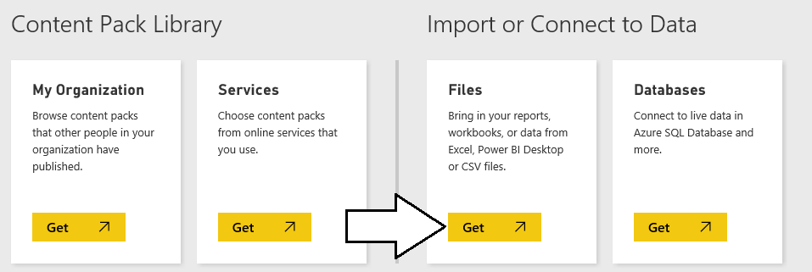

* 1. On the next page you should see several tiles which indicate your choices for the location of the file you would like to connect to or import. Click on the tile with the caption **Local File** so you can import a PBIX file from inside your student folder.

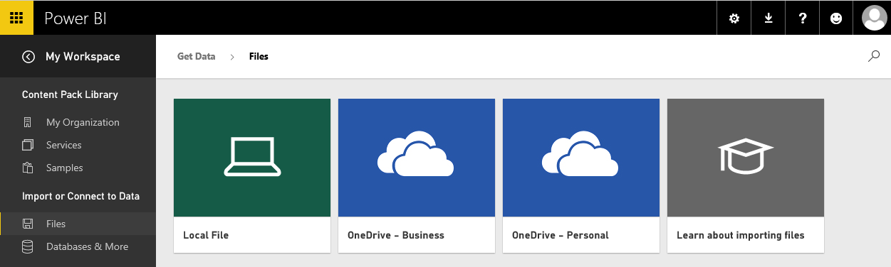

* 1. When prompted with the **Open** dialog, select the PBIX file named **C:\Student\PBIX\Wingtip Sales Analysis.pbix** and then click **Open**.

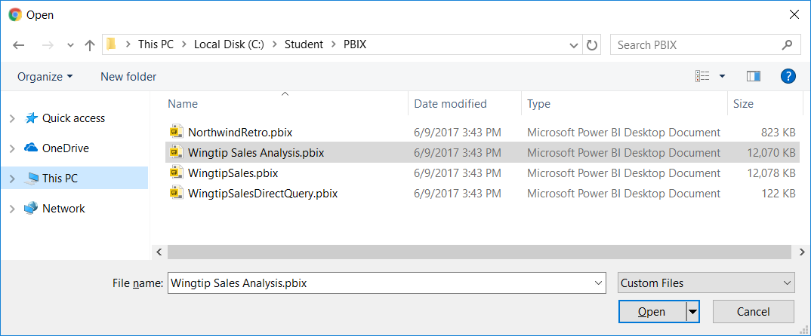

* 1. It will take the Power BI services a few seconds to complete the upload.

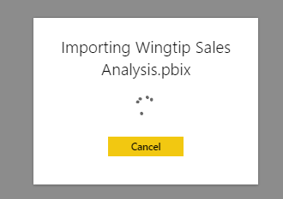

1. When the PBIX import process completes, inspect what content has added to your personal workspace.
   1. You should be able to see that the Power BI service has created a new dashboard with the same name as the PBIX file which in this case is **Wingtip Sales Analysis.pbix**. Click the **Delete** icon to delete this dashboard.

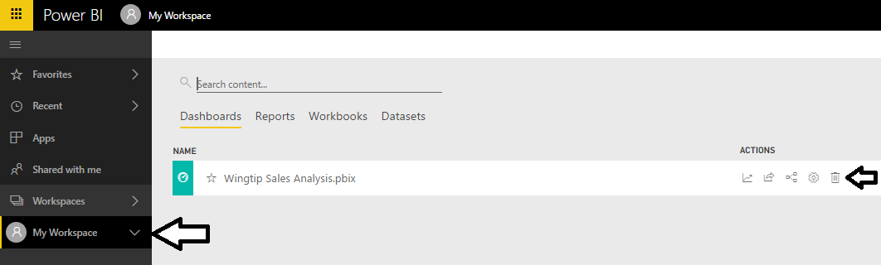

* 1. Navigate to the **Datasets** view and verify you can see a new dataset named **Wingtip Sales Analysis**.

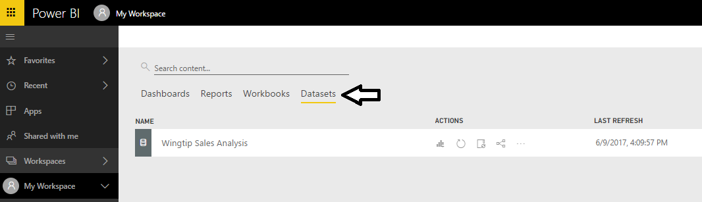

* 1. Navigate to **Reports** view and verify you can see a new report named **Wingtip Sales Analysis**. Click on the report to open it.

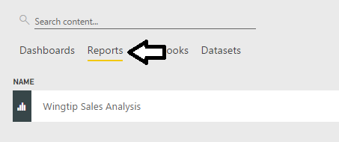

* 1. When the report opens, take a minute and inspect each of the pages in the report.

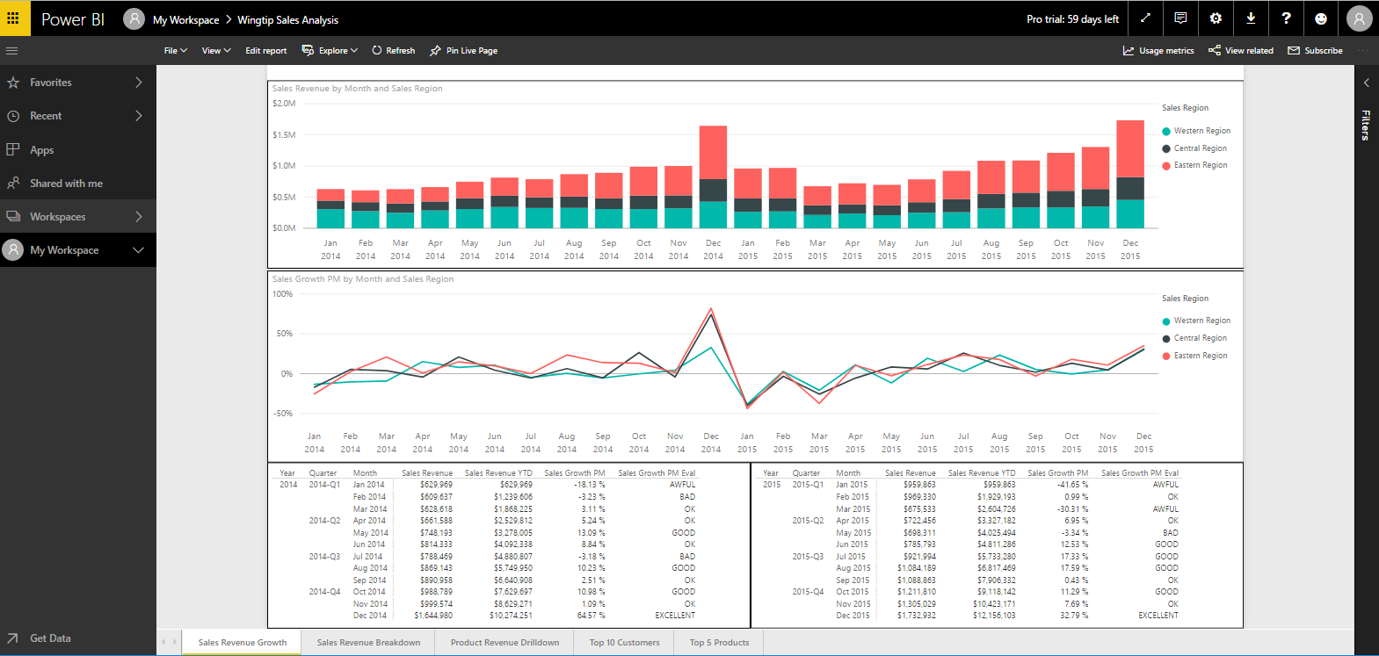

1. Create a new dashboard named **Wingtip Sales Analysis**.
   1. Return to the page named **Sales Revenue Growth**.
   2. Hover the mouse over the top right corner of the line chart visual and click the thumbtack to pin the visual to a dashboard.

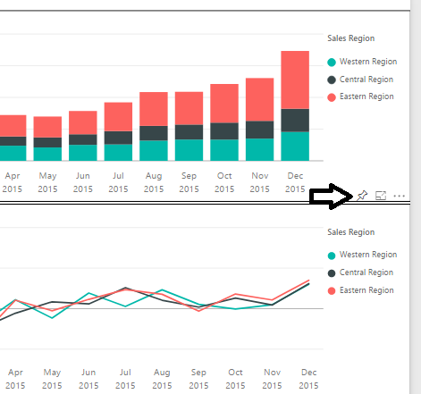

* 1. In the **Pin to dashboard** dialog, select **New dashboard** and give it a name of **Wingtip Sales Analysis**. Click the **Pin** button to create a new dashboard and add a new tile based on the line chart visual.

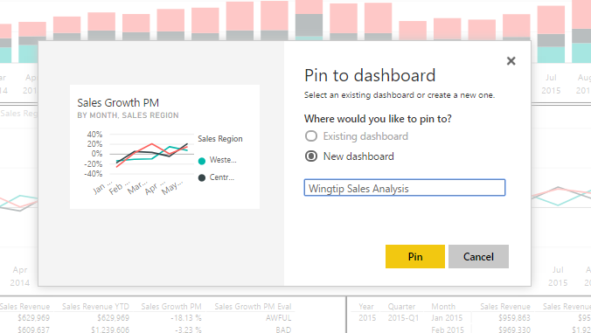

* 1. The Power BI service will display a notification when the dashboard and tile have been created.

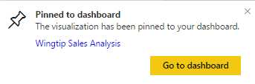

* 1. Navigate to the new dashboard which should appear as the one shown in the following screenshot.

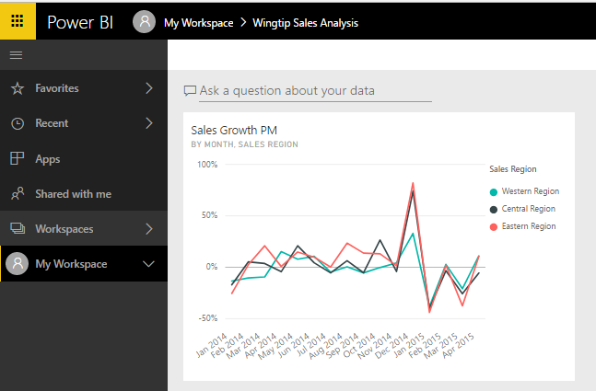

* 1. Resize the dashboard tile to make it wider.

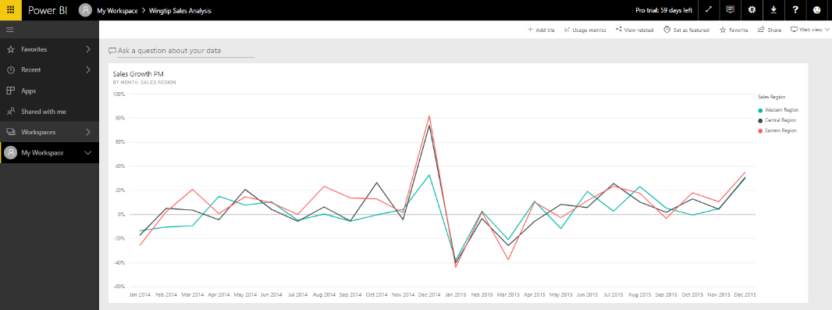

* 1. Return to the report and pin another 3-4 visuals to fill the dashboard up with a few more tiles. Try to make your dashboard look like the one shown below.

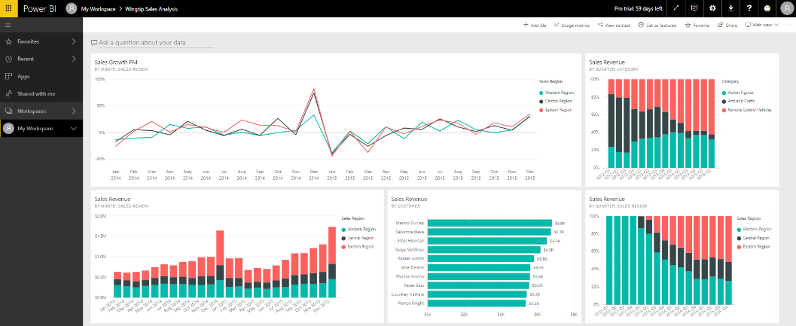

Don’t spend too much time trying to make the dashboard look pretty. At this point, it’s just important that you know how to create a dashboard and fill it with tiles created from report visuals.

### Exercise 4: Install and Configure Power BI Desktop

In this exercise, you will download and install Power BI Desktop. Note that if Power BI desktop is already installed on your developer workstation, you can skip this exercise and move ahead to exercise 5.

1. On the top right of the Power BI service window, drop down the **Downloads** menu and click the **Power BI Desktop** menu command to begin the download of the installation file.

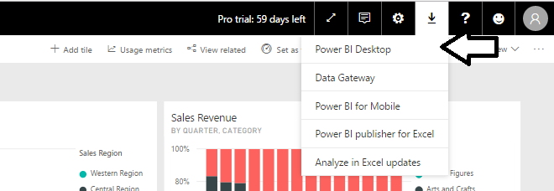

1. Wait for the MSI file to download.



1. Once the file has downloaded, click the **Run** button to begin the installation of Power BI Desktop.



1. When you see the Welcome screen, click **Next** to continue with the installation.

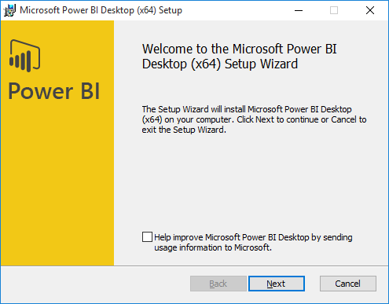

1. Click the checkbox to accept the license agreement and click **Next**.

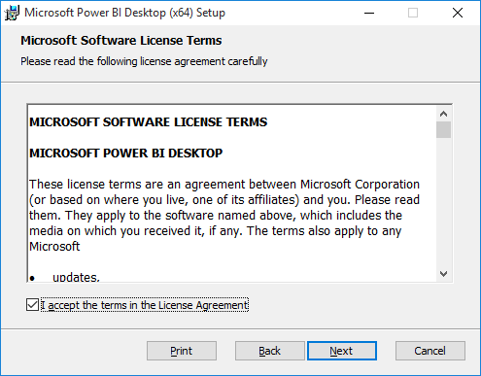

1. Accept the default location for the installation and click **Next**.

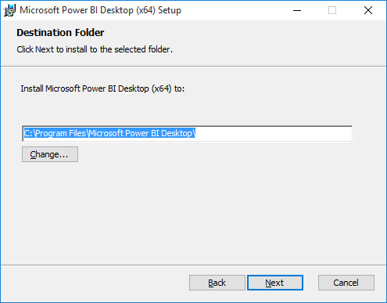

1. On the next screen, click **Install**.

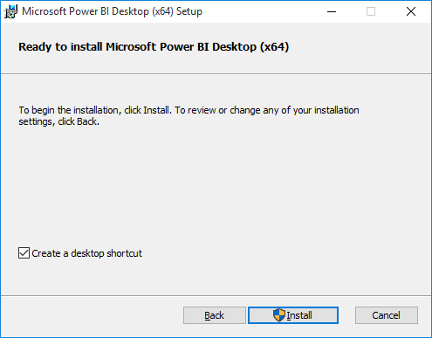

1. When you see the **Completed the Microsoft Power BI Desktop Setup Wizard** screen, click **Finish** to launch Power BI Desktop.

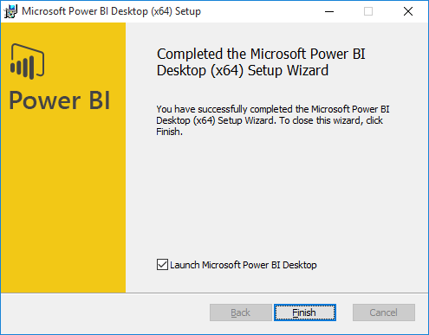

1. When Power BI Desktop launches for the first time, it displays a Welcome screen as shown in the following desktop. Click the (**X**) button in the upper right corner to close this window.

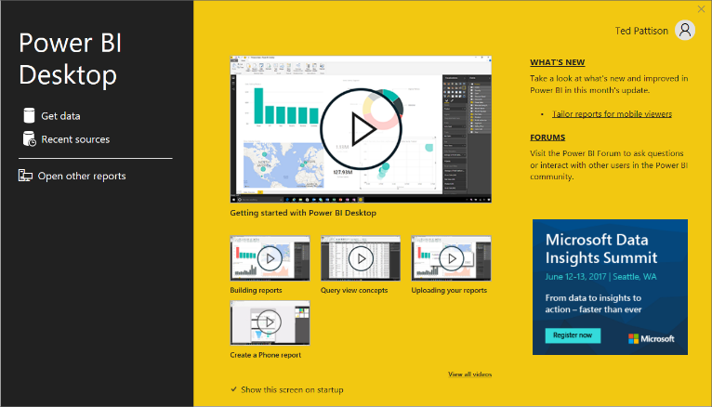

1. At this point, you should have Power BI Desktop running as shown in the following screenshot.

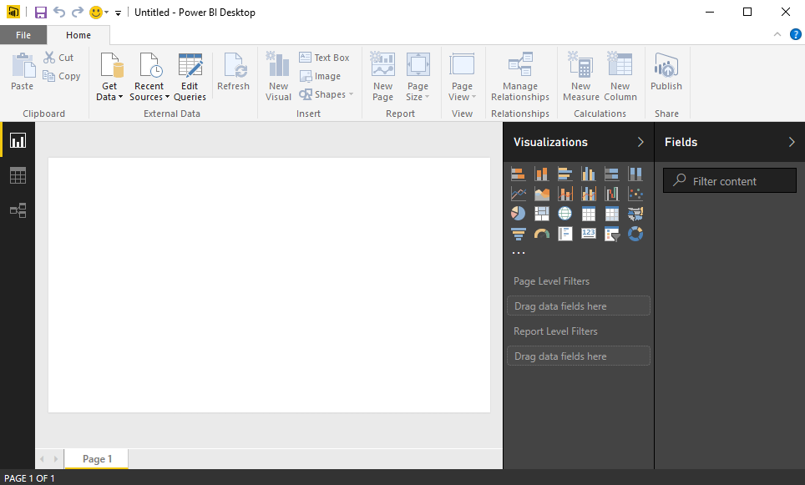

You are now ready to move ahead to the next exercise.

### Exercise 5: Publish a Project with Power BI Desktop

sss

1. Launch Power BI Desktop if it’s not already running.
2. xxxx

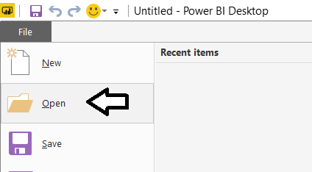

* 1. ccc

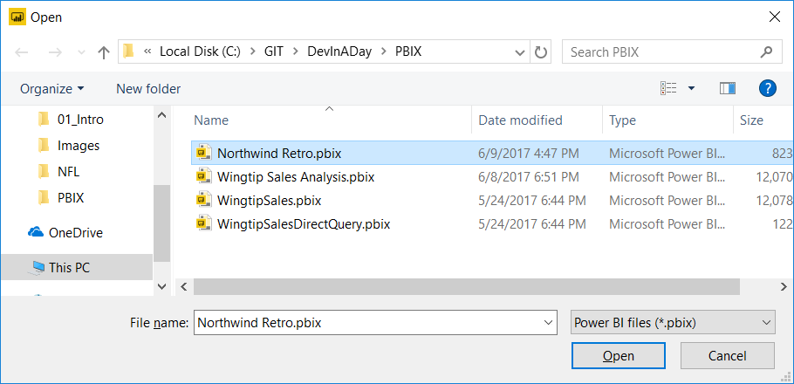

* 1. xxxx

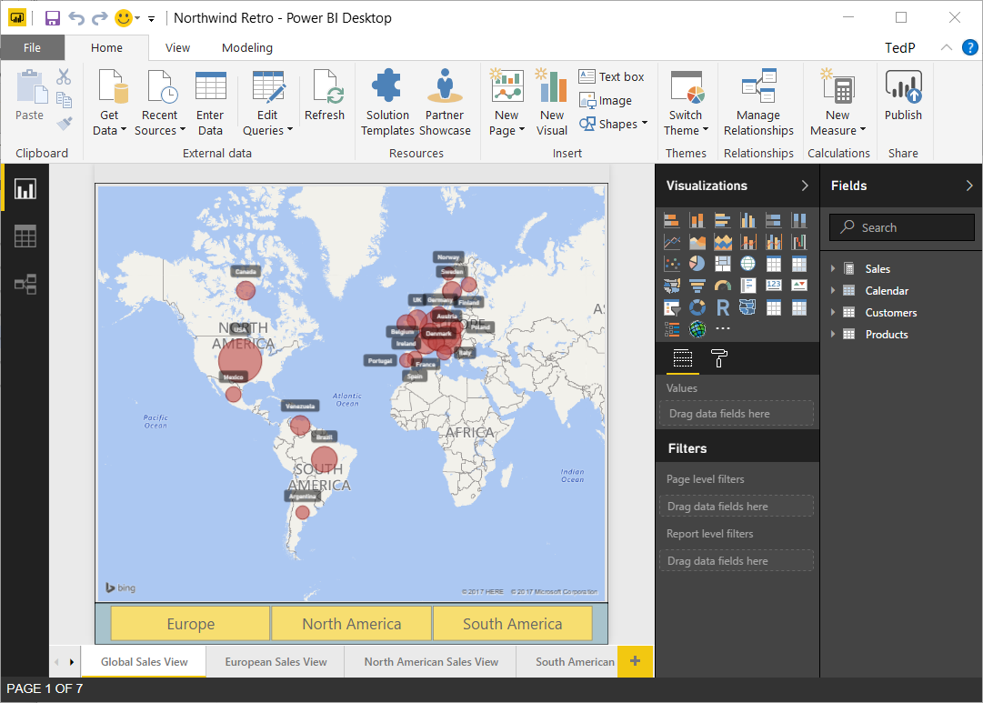

* 1. xxxx

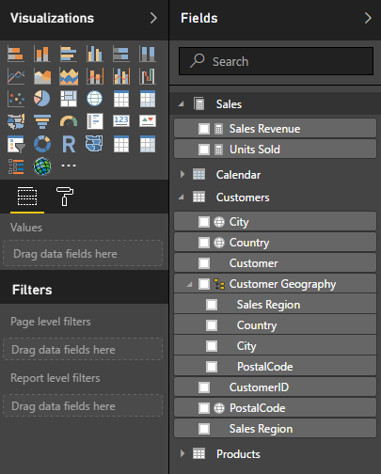

* 1. xxxx

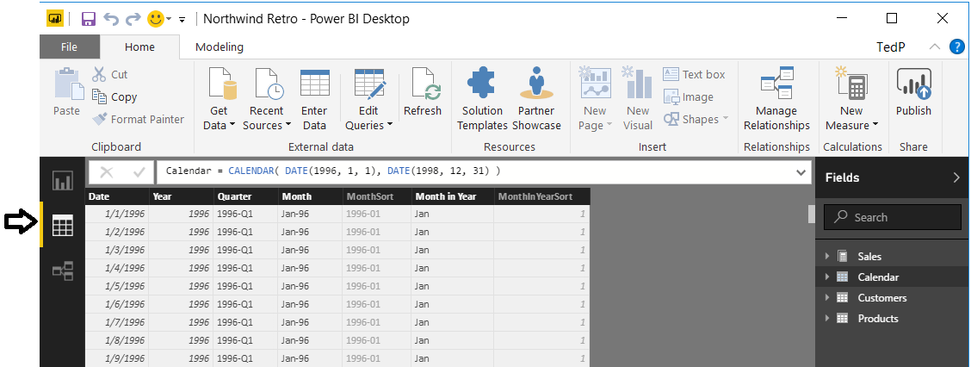

* 1. xxxx

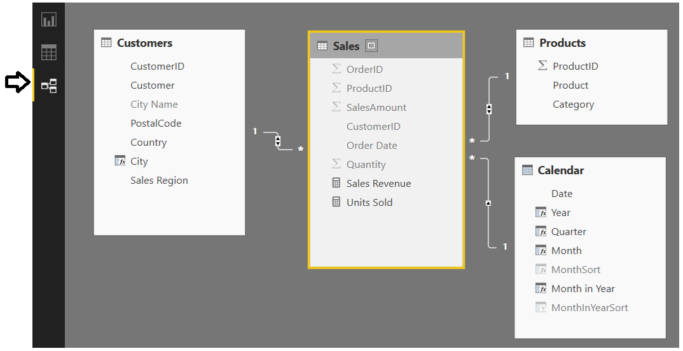

* 1. xxxxx

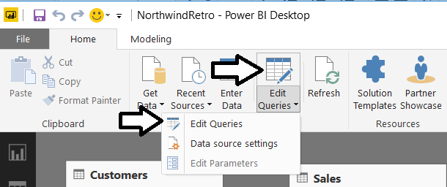

* 1. xxxxx

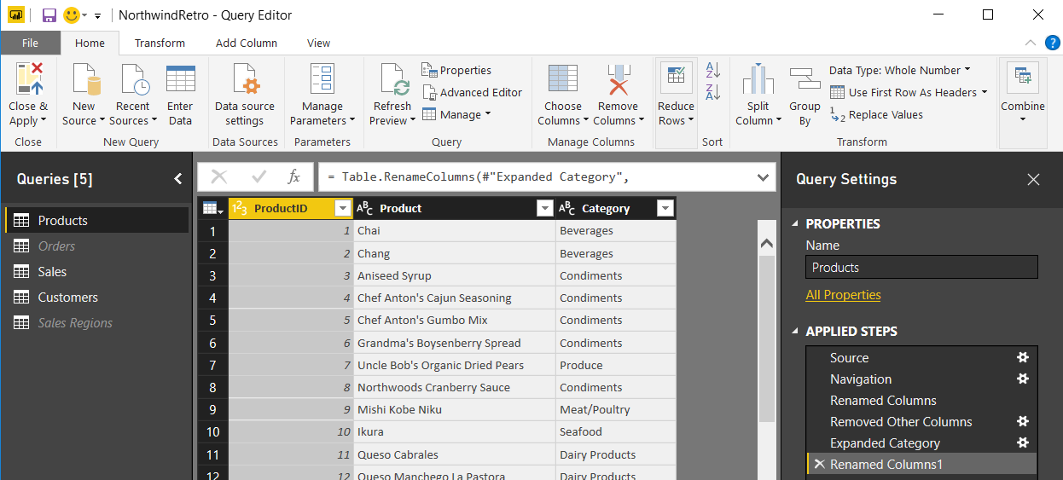

* 1. xxxx

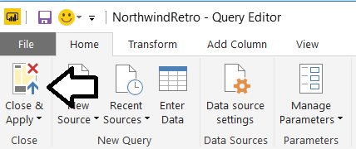

* 1. xxx

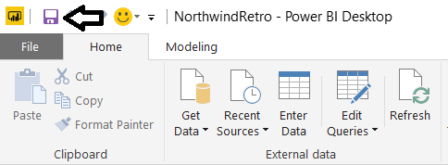

* 1. xxxx

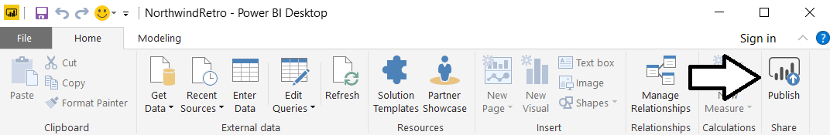

* 1. xxx

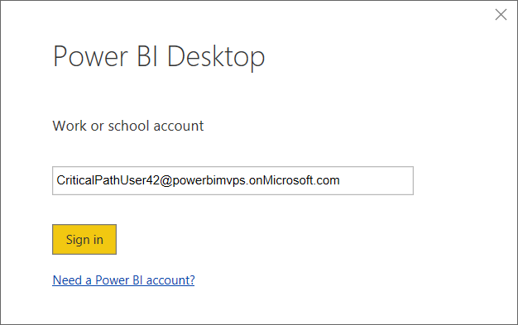

* 1. xxxx

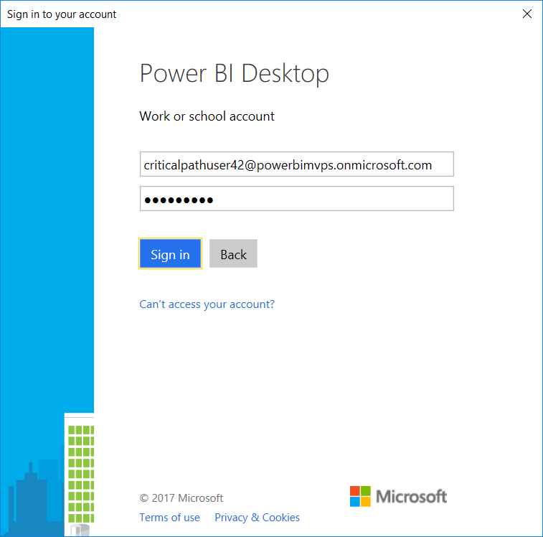

* 1. xxxx

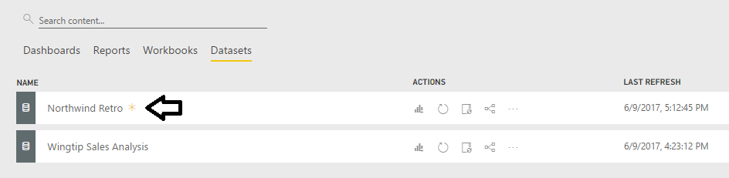

* 1. xxxxx

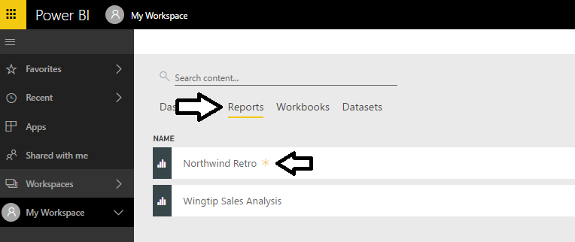

* 1. xxxx

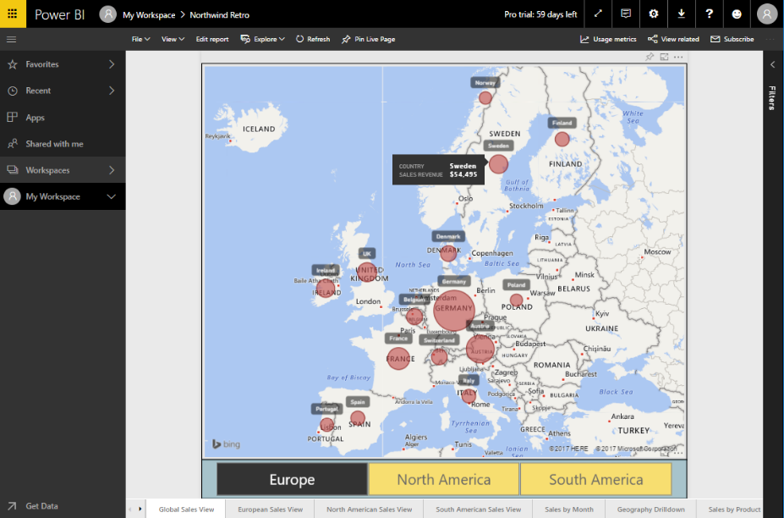

xxxx

### Exercise 6: Create a New App Workspace to Build a Custom Solution

xxxx

1. xxx

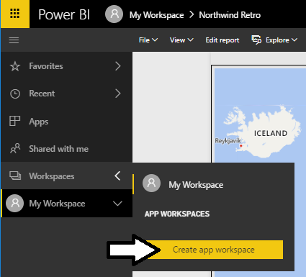

* 1. xxx

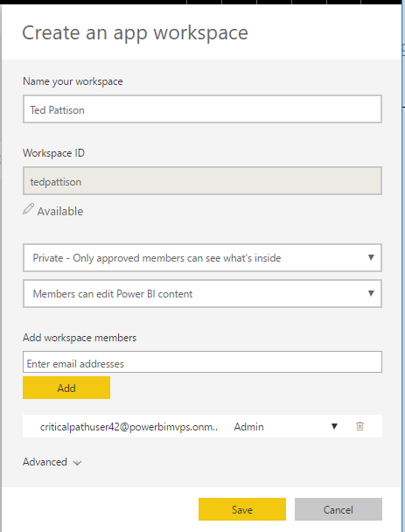

* 1. xxxx

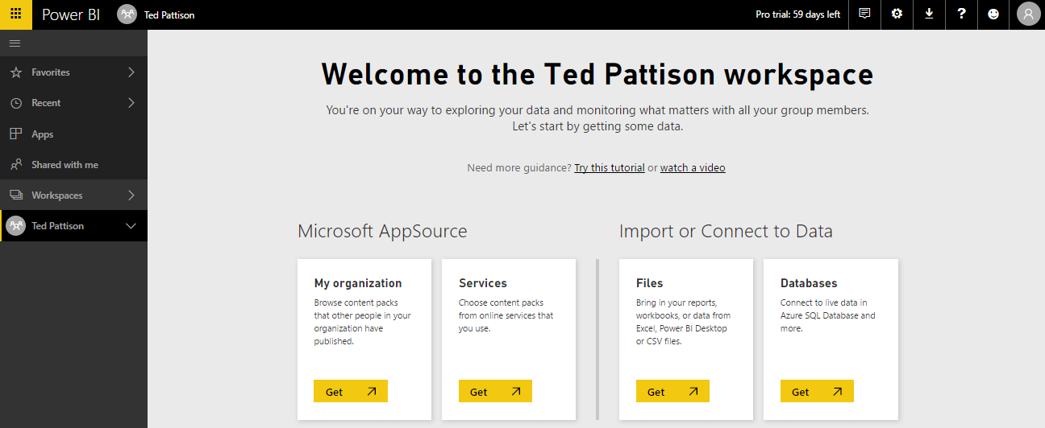

* 1. xxxx

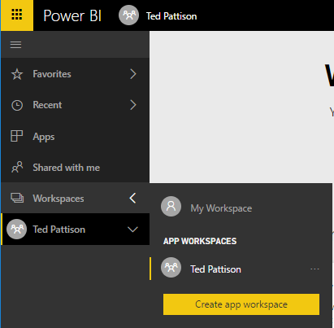

* 1. xxx

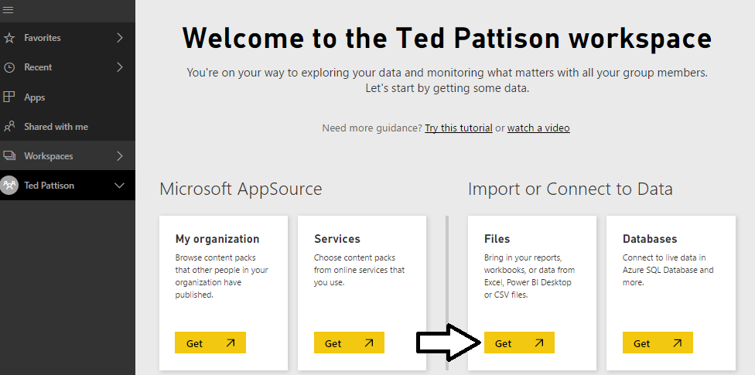

* 1. xxx

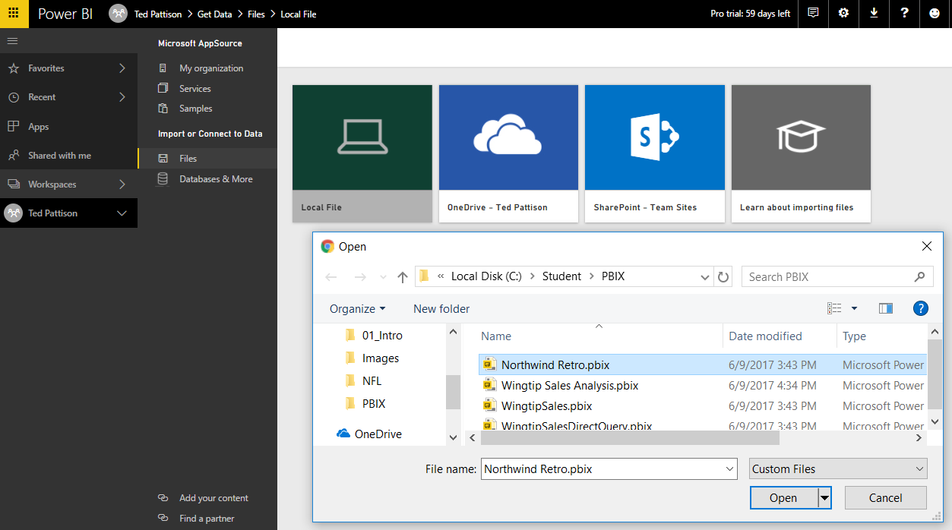

* 1. xxxx

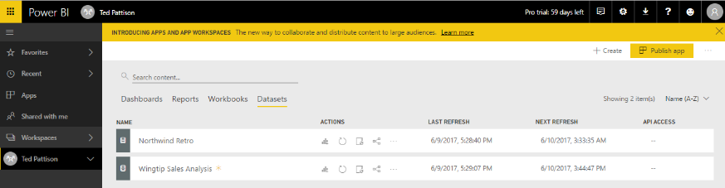

* 1. xxx

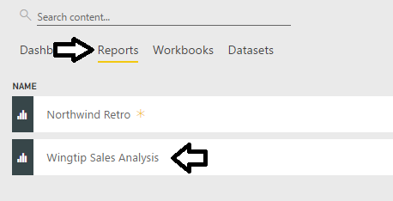

* 1. xxx

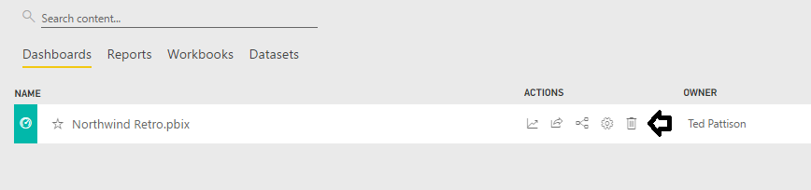

* 1. xxxx

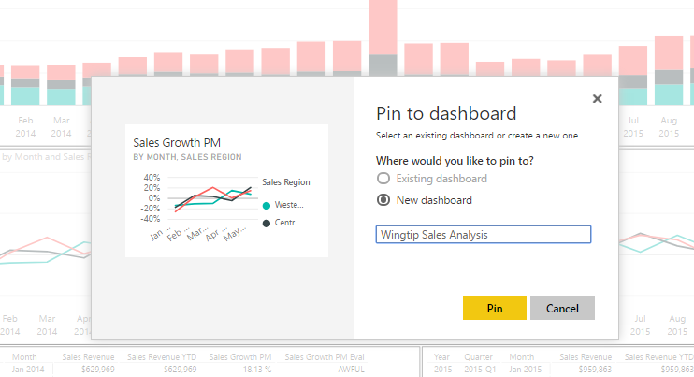

* 1. xxx

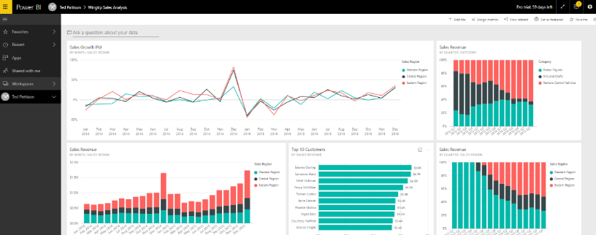

xxxx

### Exercise 7: Embed a Power BI Report in a Web App using the Publish to Web Feature

Xxxx

1. Create a new Visual Studio project named **HelloPowerBiEmbedding**.
   1. ccccc

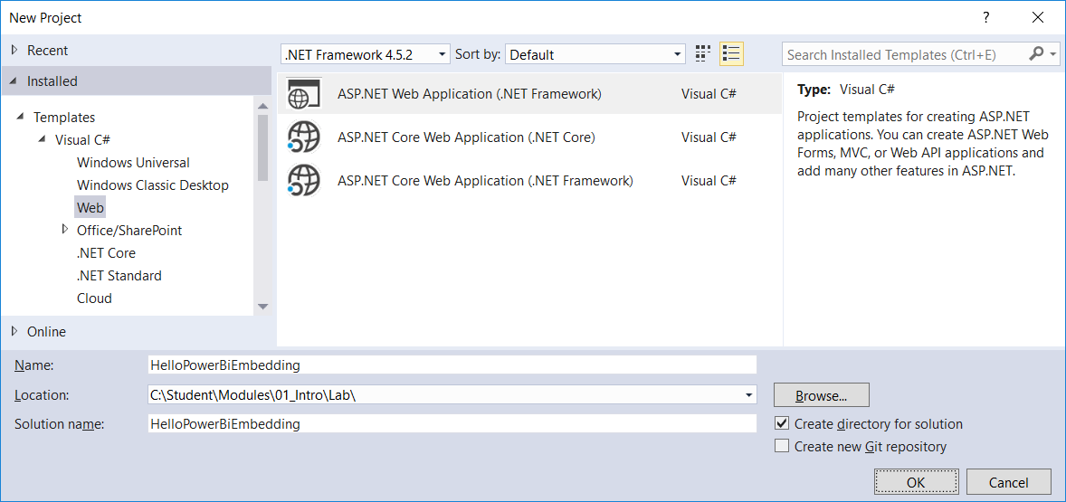

* 1. xxx

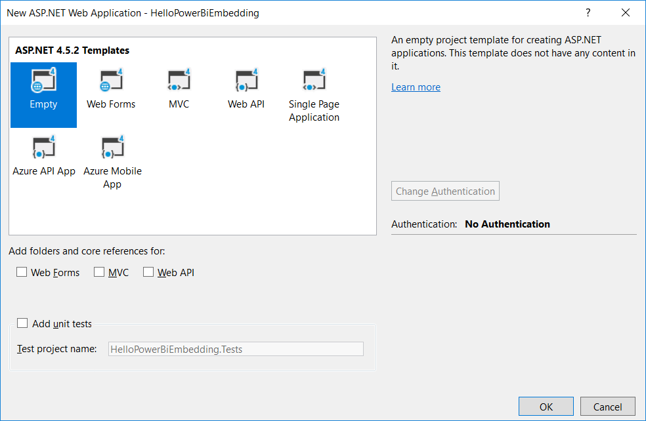

* 1. xxxx

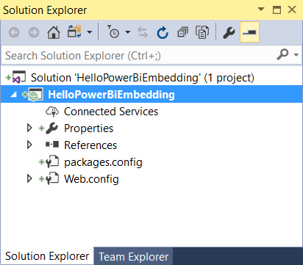

* 1. xxxx

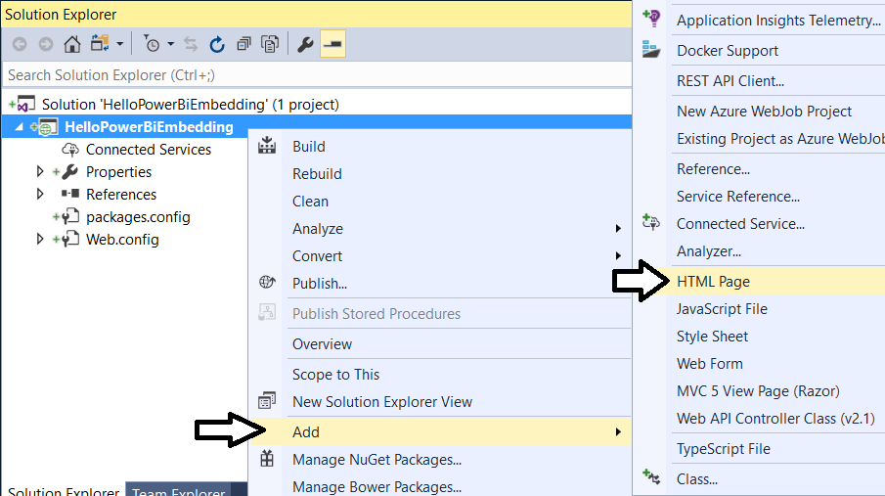

* 1. xxxx

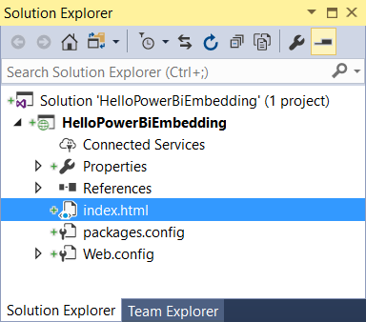

* 1. xxxx

<!DOCTYPE html>

<html>

<head>

<meta charset="utf-8" />

<title>Hello PBI Embedding</title>

</head>

<body>

<h2>Hello Power BI Embedding</h2>

<div>

<!-- TODO: Embed Power BI Report Here-->

</div>

</body>

</html>

1. Debug

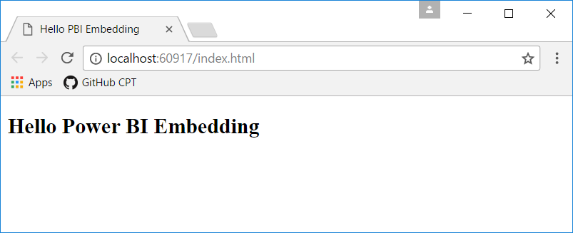

1. Xx
   1. xxxx

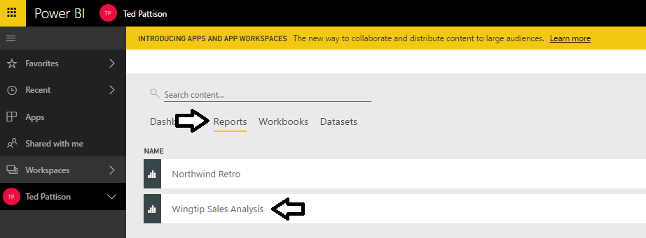

* 1. xxxx

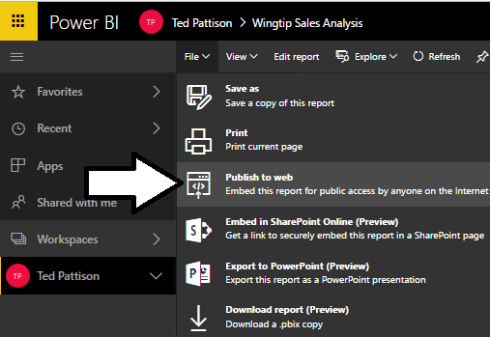

* 1. xxxx

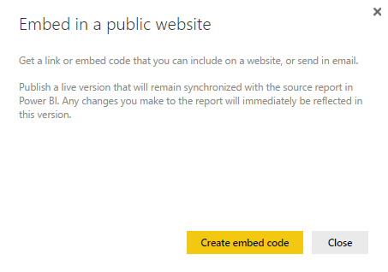

* 1. ccc

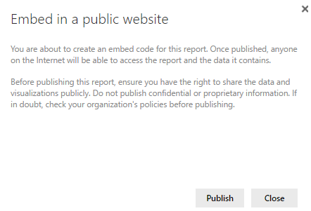

* 1. cccc

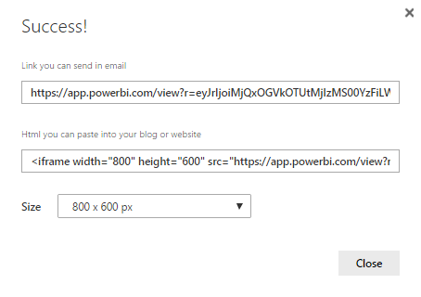

* 1. xxxxx

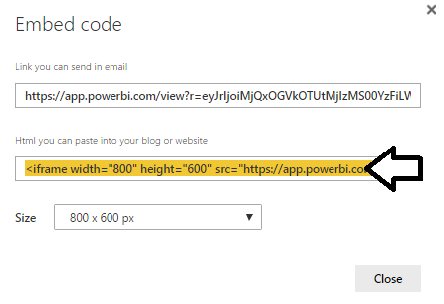

* 1. xxx

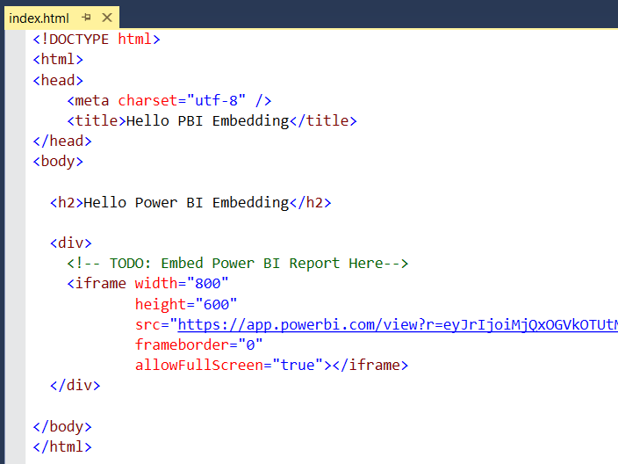

* 1. xxx

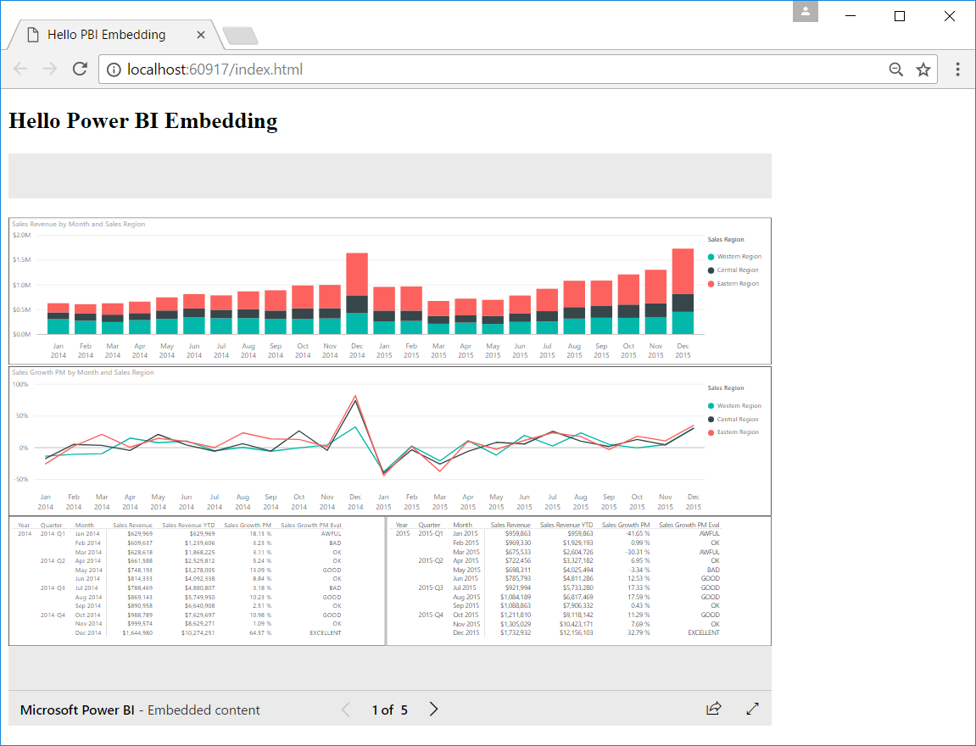

xxxx